Aws Practice

Install aws cli 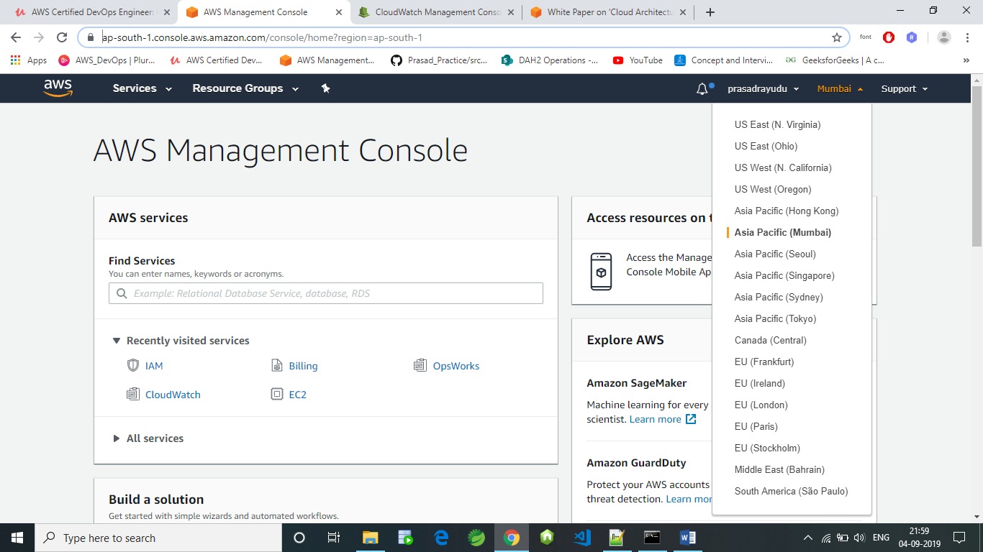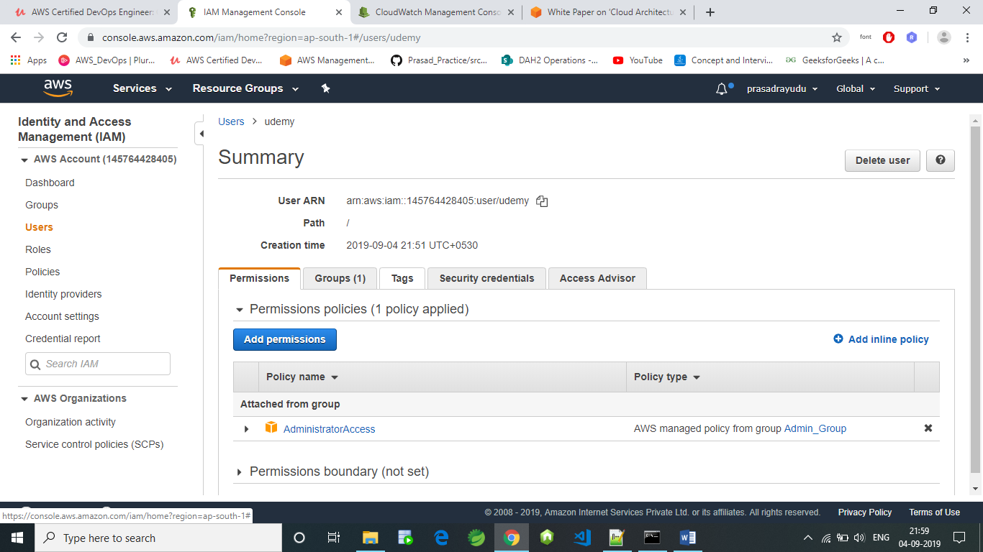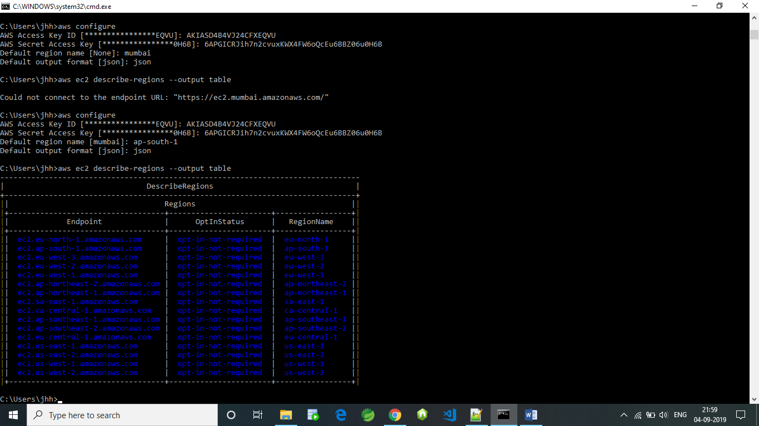

S3 :- static storage service

aws s3 mb s3://newcdbucketprasad

mb :- make bucket – rb – remove bucket

aws s3 rb s3://newcdbucketprasad

